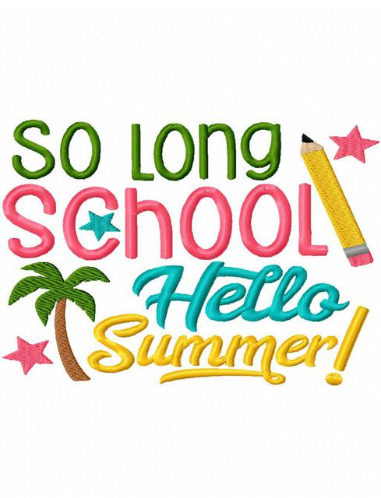*Once again, another school year is coming to a close. Thank you so much for letting me be your child’s school nurse!  There are several important announcements and reminders that I would like to bring to your attention:*

Summer Newsletter

from Nurse Kris

1. **Please remember to pick up** all student medications from the nurse’s office, as they will be discarded on the last day of school, **May 21st 2020.** A parent or guardian must pick up medications by **11:30 AM** as this is a ½ day, any medications left will be disposed of. Medications cannot be stored in the nurse’s office over the summer and medications cannot be sent to DMS for upcoming 6th graders.
2. Also, 2020-2021 School Medication Authorization forms can be picked up in the nurse’s office or printed off the Tuscaloosa County School website at [www.tcss.net](http://www.tcss.net). An updated authorization form must be completed and signed by your doctor and brought to school with the medication next school year in order for medication to be administered by the nurse.
3. All blue immunization cards must be up-to-date before your child will be placed on a class roll.

Just a few tips to have a safe, healthy, happy SUMMER!

1. Apply sunscreen 30 minutes before going outside and reapply every hour.
2. Stay hydrated! Drink lots and lots of water.



1. NEVER swim without an adult present!
2. Stay active! Run, walk, stretch, swim, PLAY!!
3. Read a book…..or several to keep your mind smart!